**Concat:**

Concatenates two fields of type chararray or two fields of type bytearray.

Syntax:

CONCAT (expression, expression)

Loading the file1 file into file1_loading:

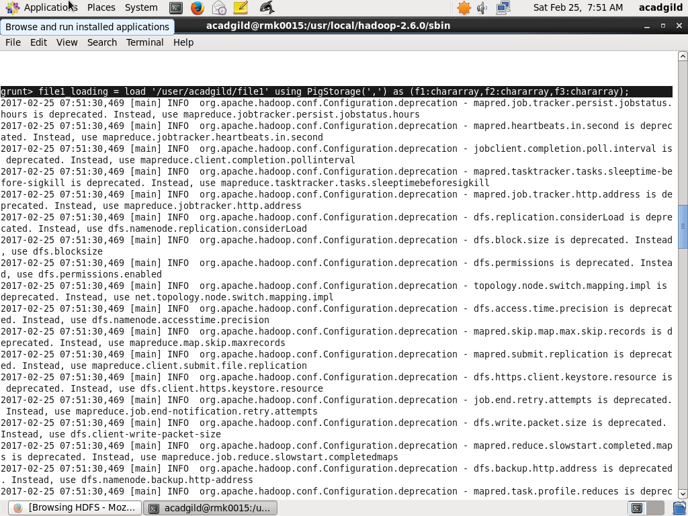

Dump the file1_loading:

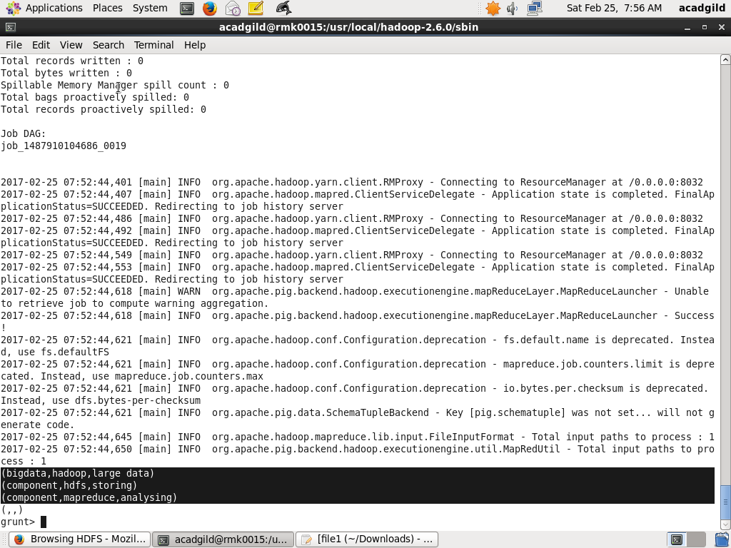

Apply the concat operation into file1_loading and give the name as file1_concat:

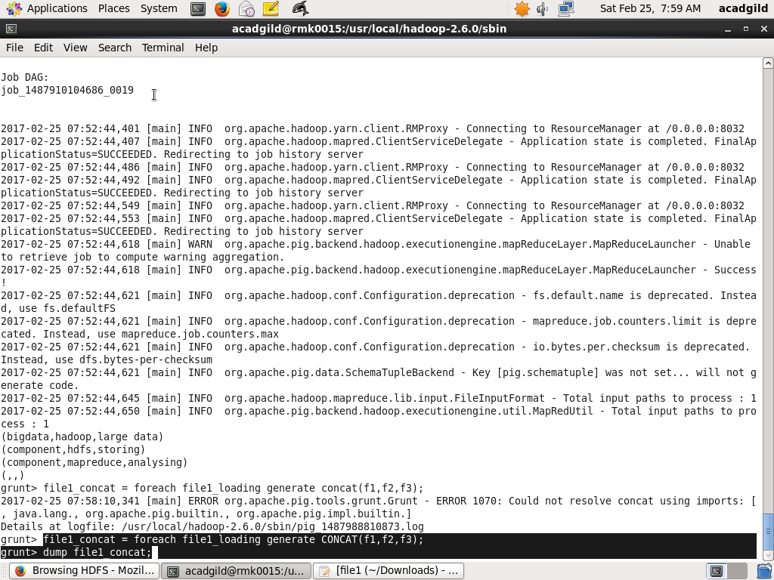

Dump the file1_concat:

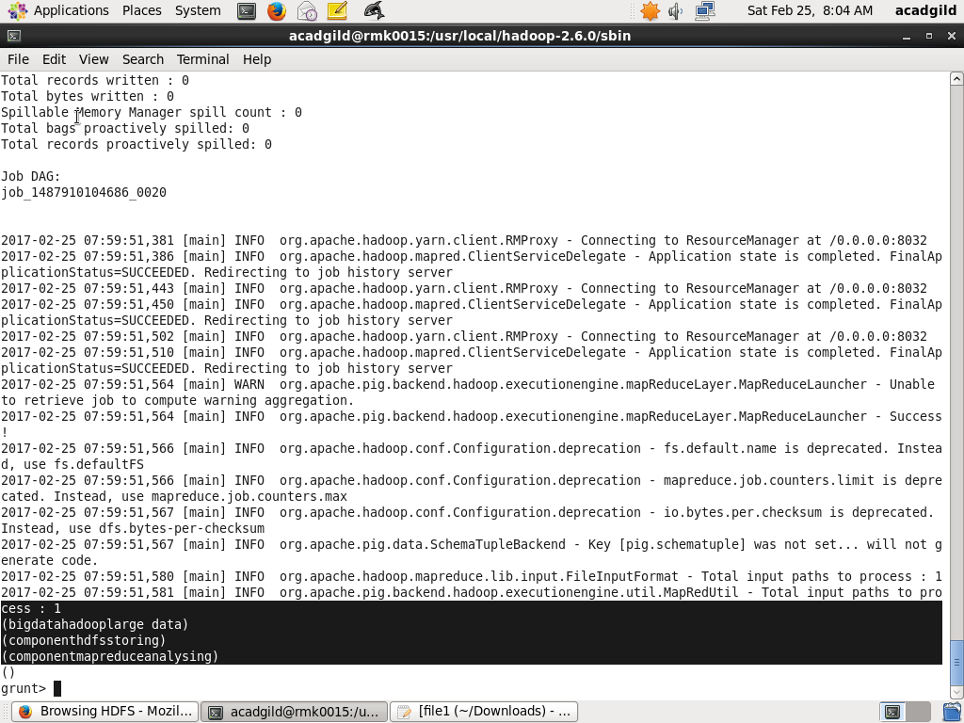

**TOKENIZE:**

Splits a string and outputs a bag of words.

Syntax:

TOKENIZE(expression)

Loading the file2 into file2_loading:

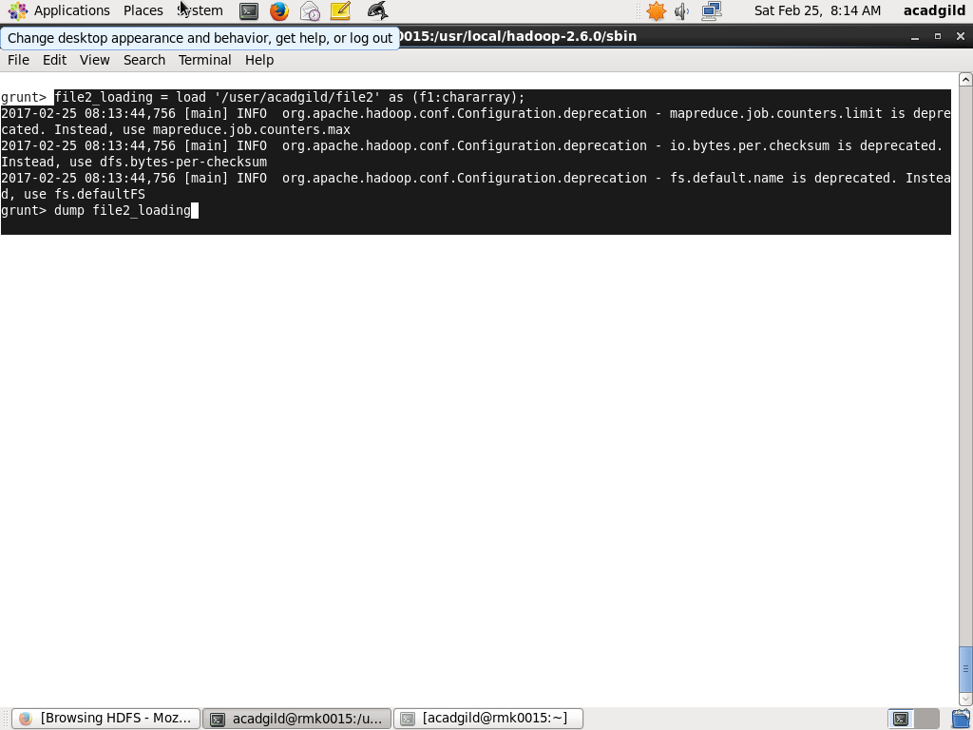

Dump the file2_loading:

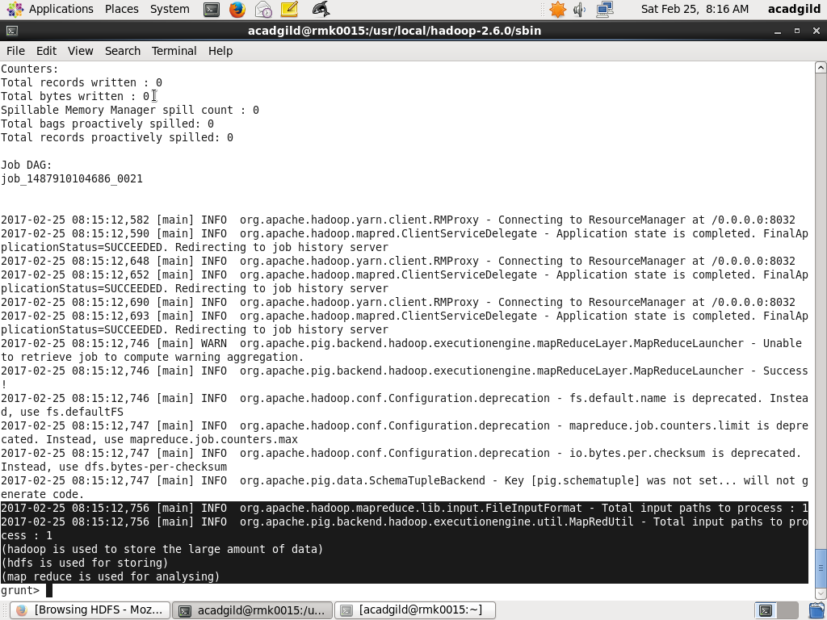

Apply the TOKENIZE command into file2_loading and the name as file2_tokenize:

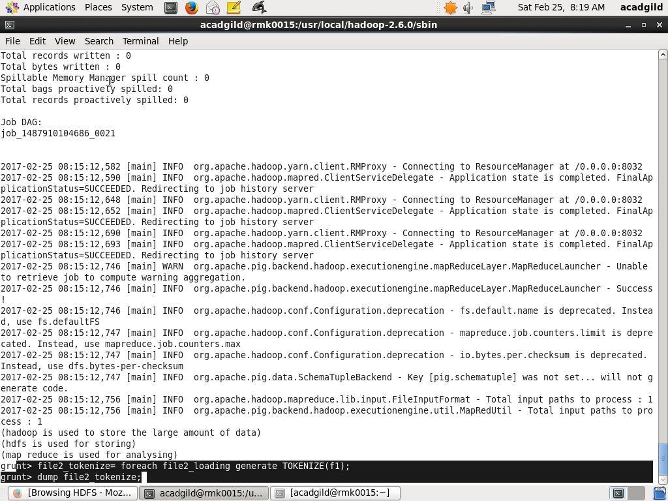

Dump the file2_tokenize:

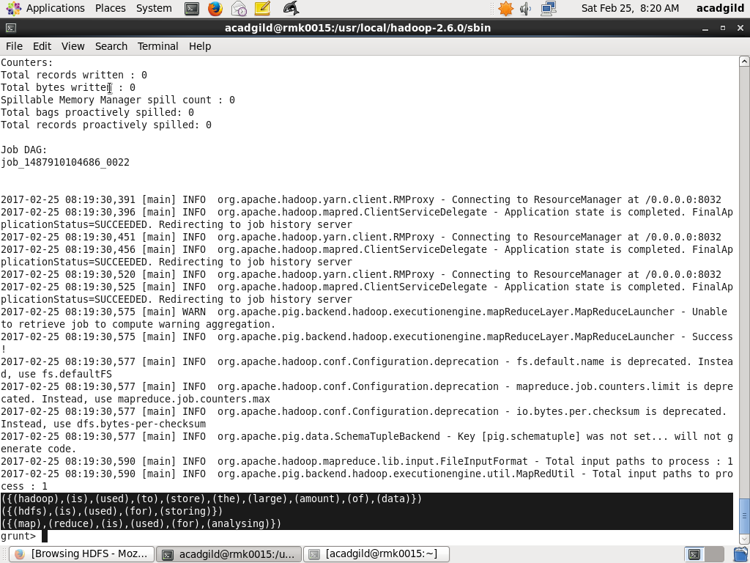

**SUM:**

Computes the sum of the numeric values in a single-column bag. SUM requires a preceding GROUP ALL statement for global sums and a GROUP BY statement for group sums.

Syntax:

SUM(expression)

Load the file4 into file4_loading:

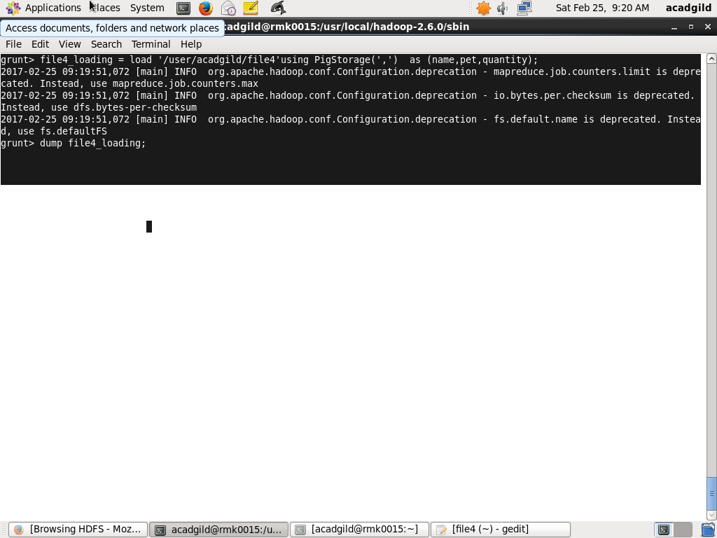

Dump the file4_loading:

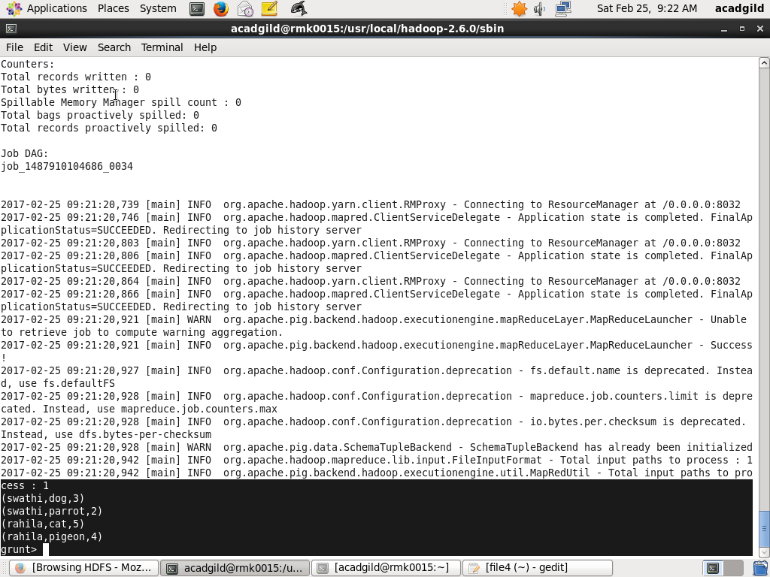

Group the file4_loading file by name:

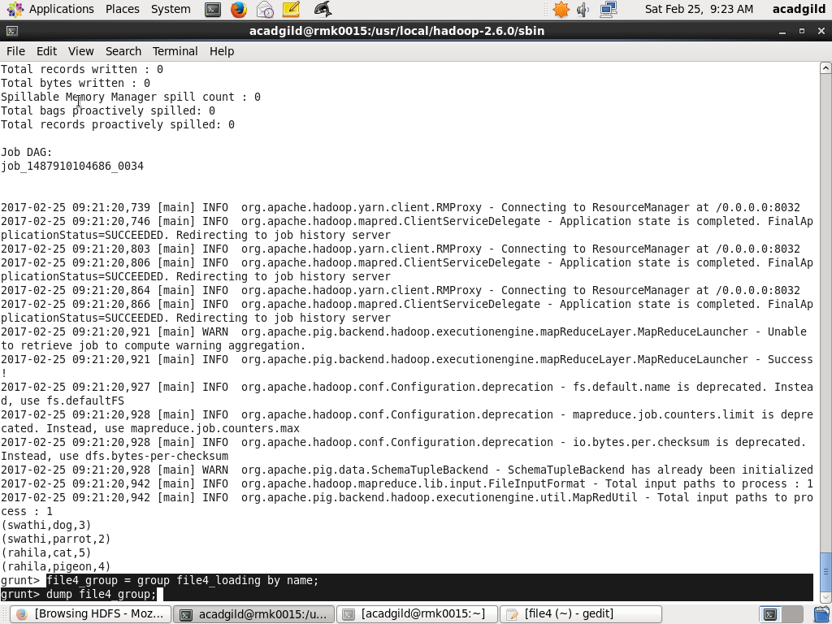

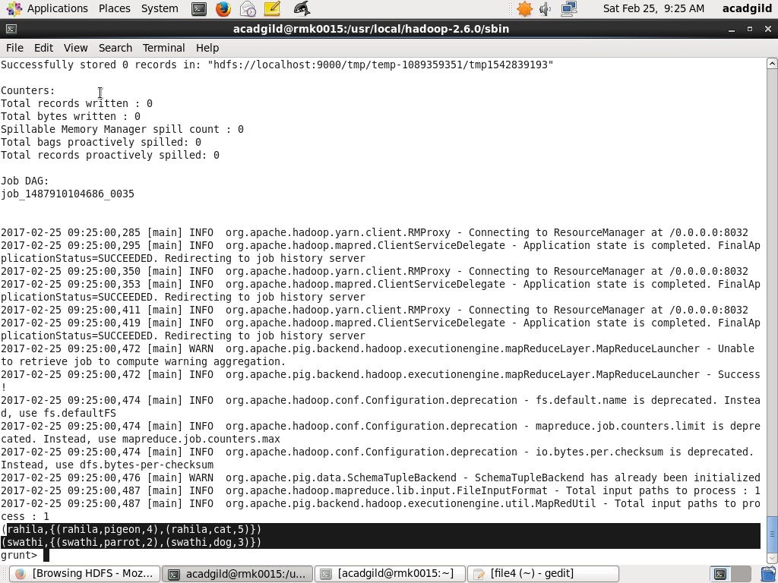

Sum the quantity and give the name as file4_sum:

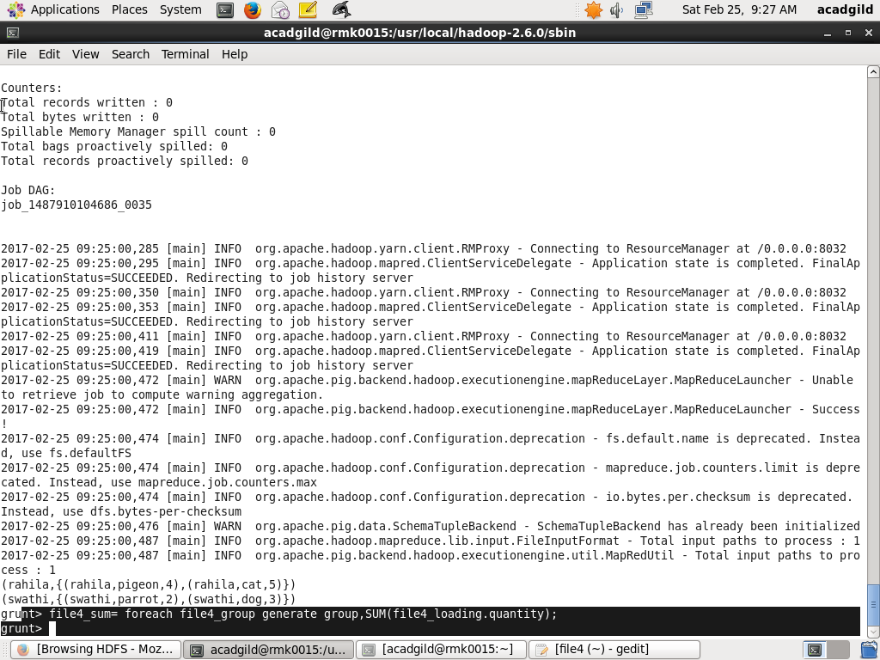

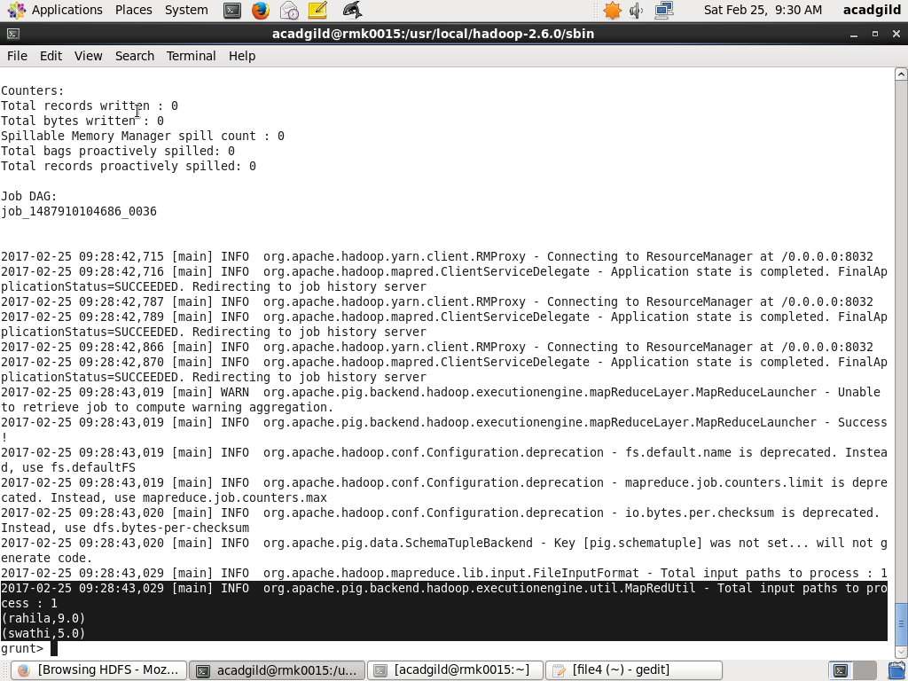

**MIN:**

Computes the minimum of the numeric values or chararrays in a single-column bag.

Syntax:

MIN(expression)

Load the file4 into file4_loading:



Dump the file4_loading:



Group the file4_loading file by name:





Min the quantity and give the name as file4_min:

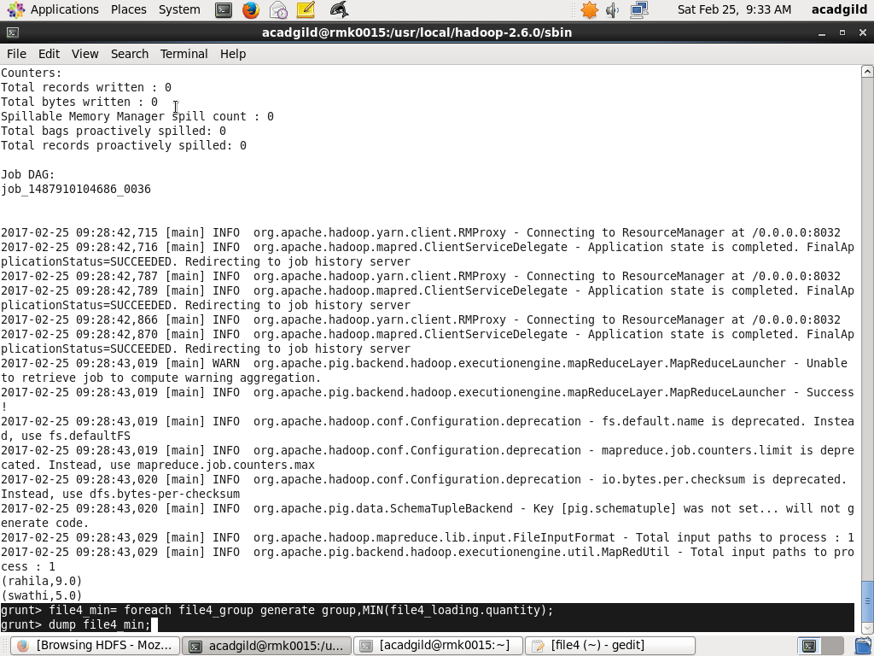

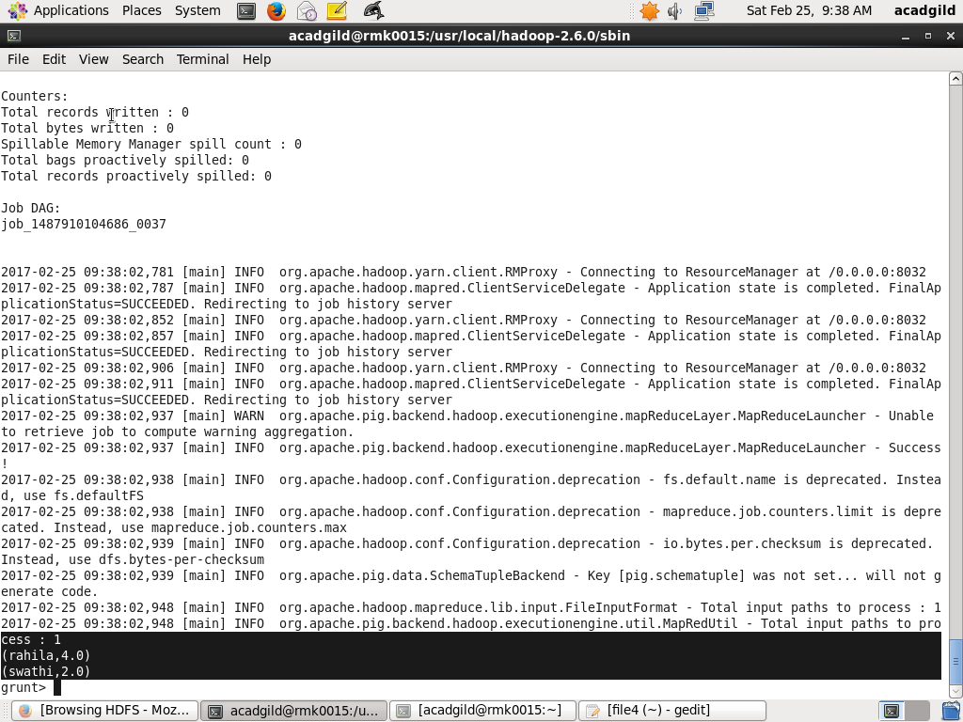

**MAX:**

Computes the maximum of the numeric values or chararrays in a single-column bag.

Syntax:

MAX(expression)

Apply the maximum comment on file4_group:

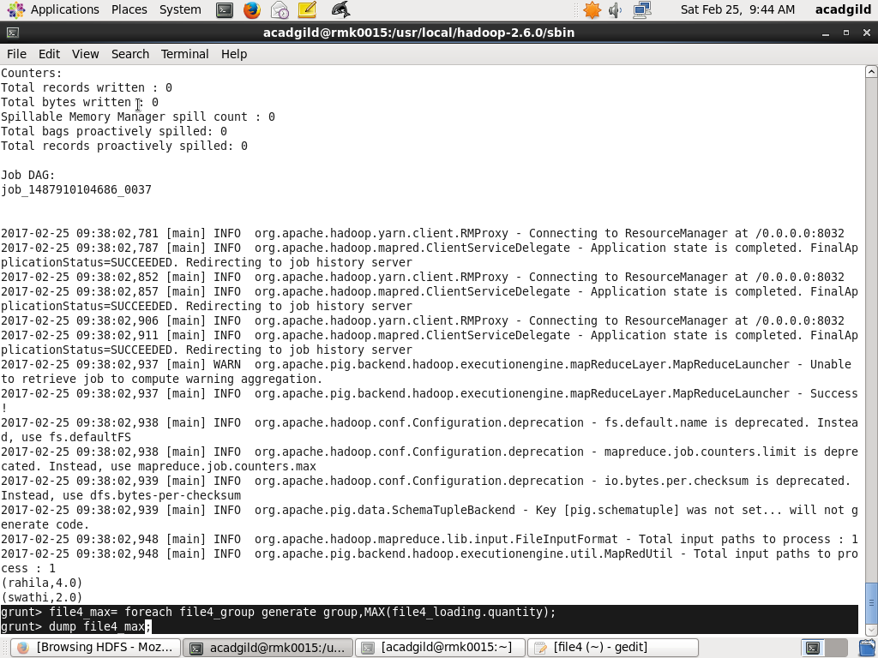

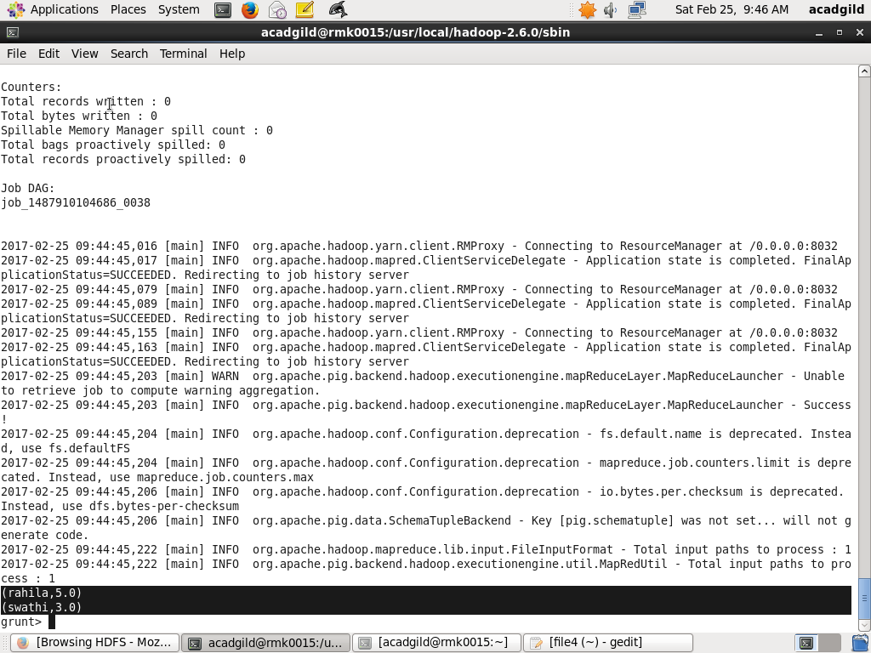

**LIMIT:**

Limits the number of output tuples.

Syntax:

alias = LIMIT alias  n;

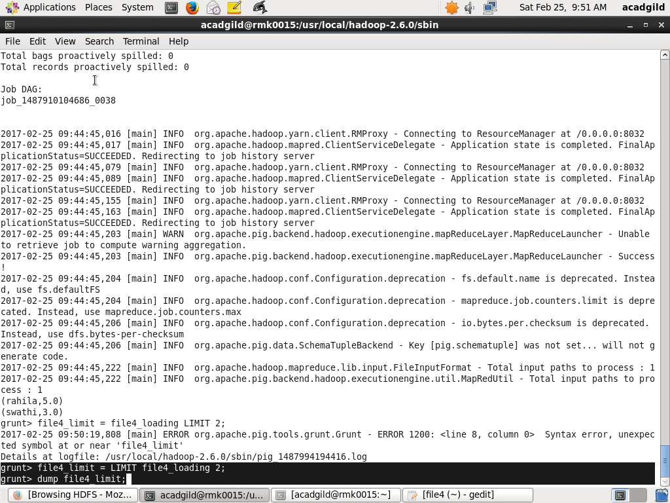

The LIMIT operator is used to output the first three tuples.

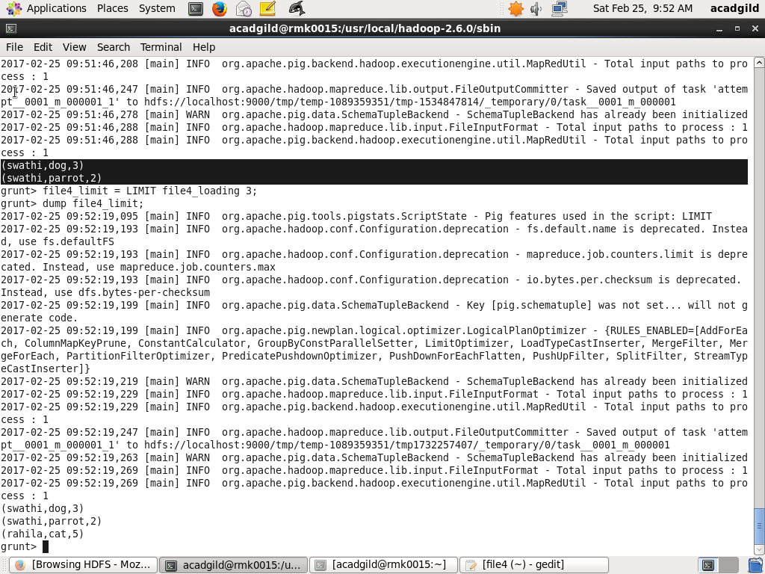

**STORE:**

Stores or saves results to the file system.

Syntax:

STORE alias INTO 'directory' [USING function];

Store the file4_loading into file_store:

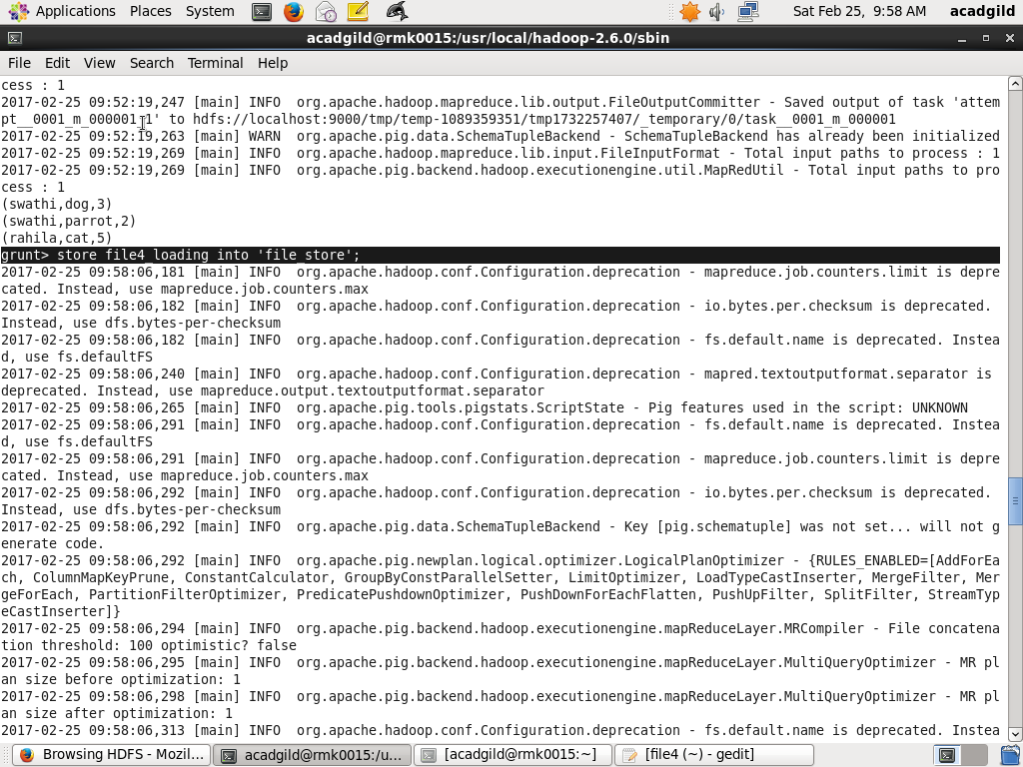

Using cat command the data is displayed:

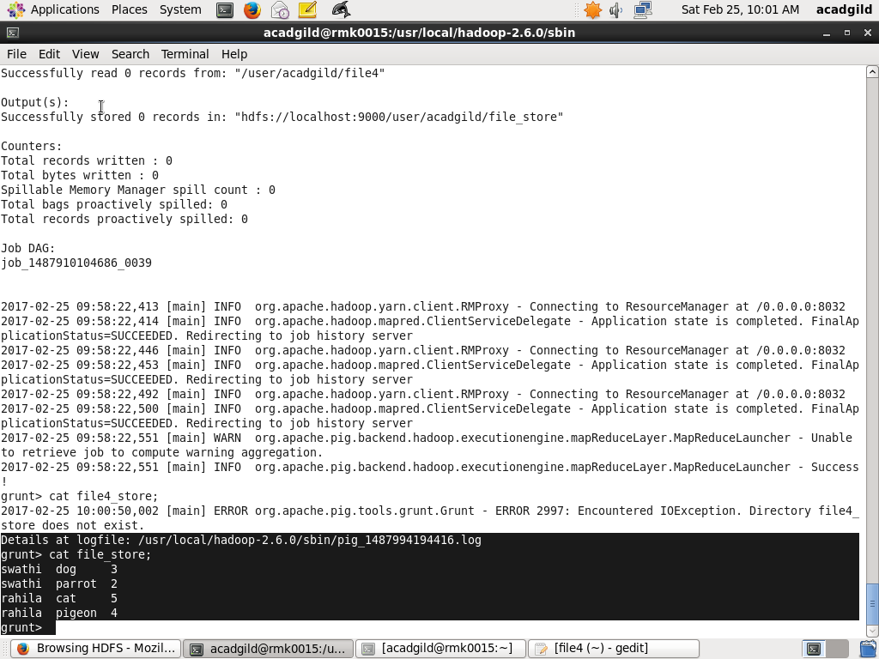

File_store is loaded into file4_loading4 file:

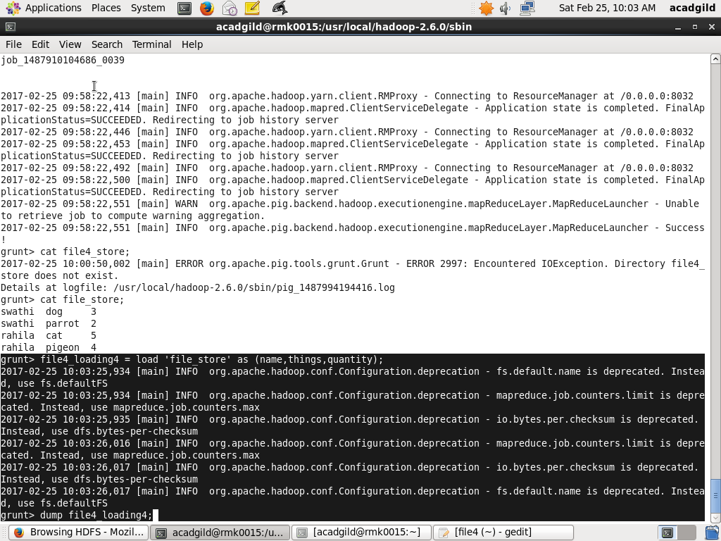

Using dump statement the file is displayed:

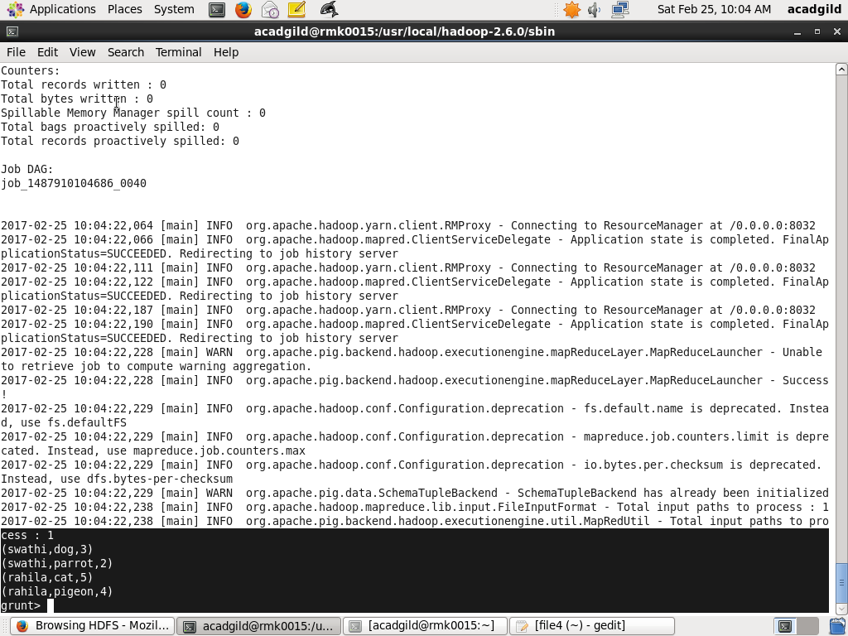

**DISTINCT:**

Removes duplicate tuples in a relation.

Syntax:

alias = DISTINCT alias [PARALLEL n];

Create the file5 with duplicates data and it is loaded into file5_loading:

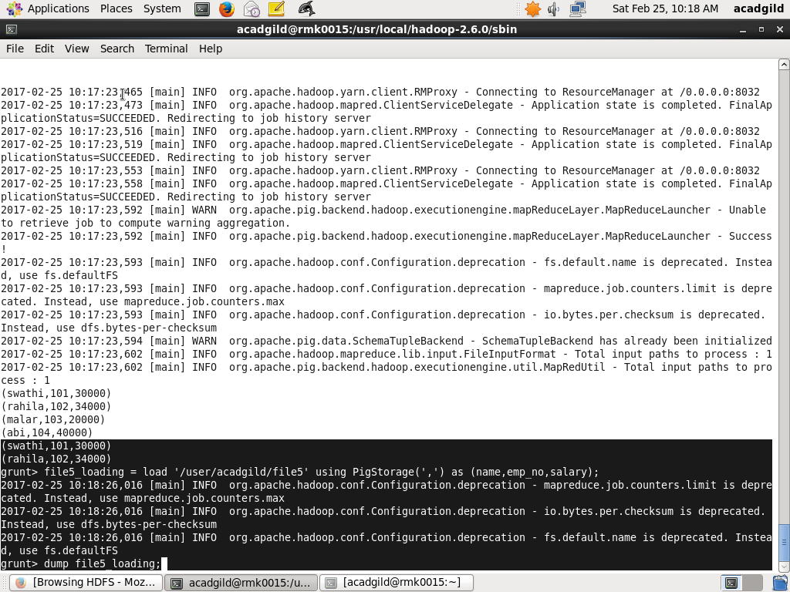

Display the content usinmg dump statement:

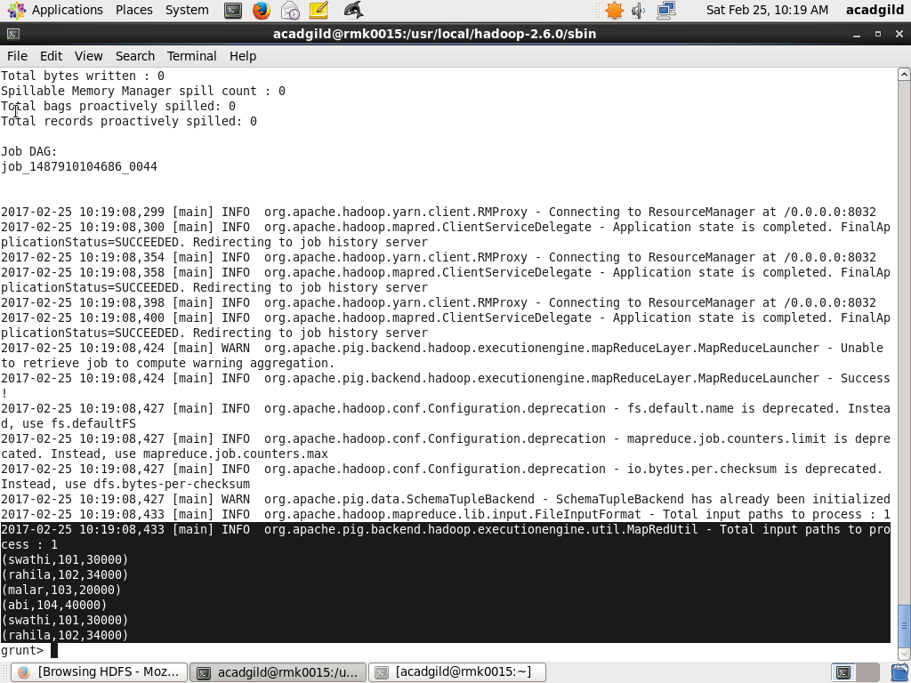

Apply the distinct command into file5_loading and give the name as file5_distinct:

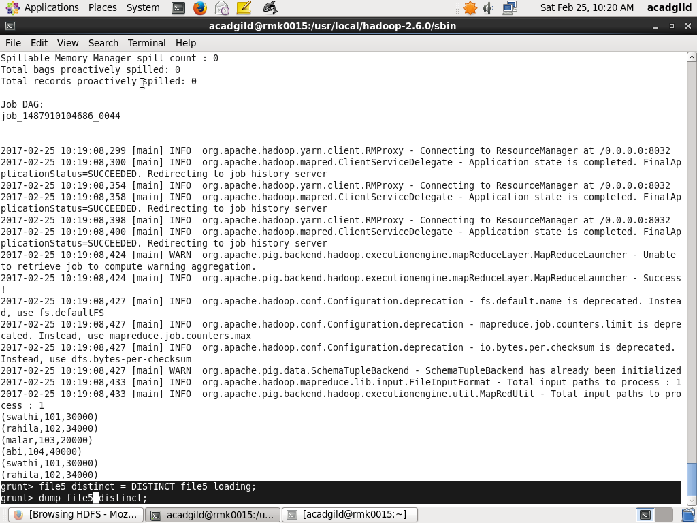

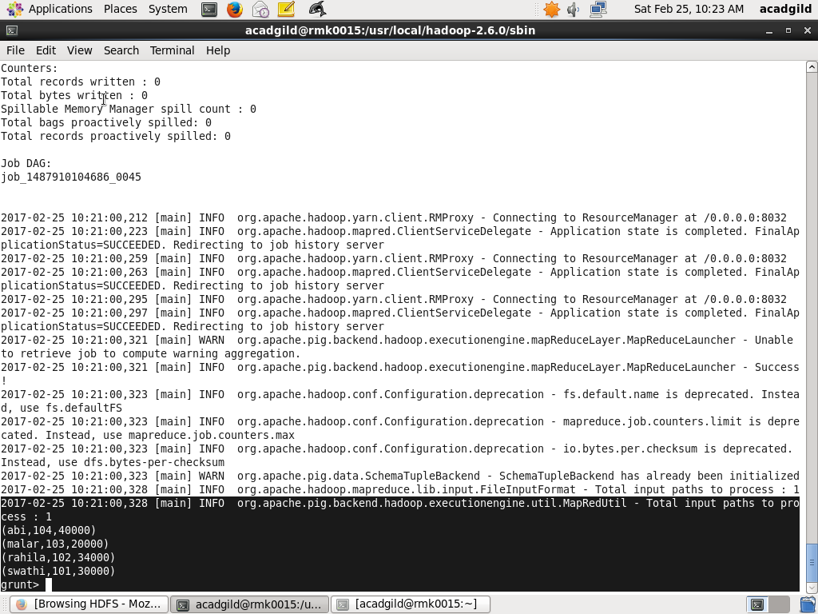

**FLATTEN:**

The FLATTEN operator looks like a UDF syntactically, but it is actually an operator that changes the structure of tuples and bags in a way that a UDF cannot. Flatten un-nests tuples as well as bags. The idea is the same, but the operation and result is different for each type of structure.

Syntax:

{(data_type) |  (tuple(data_type))  | (bag{tuple(data_type)}) | (map[]) } field

Create the file which is file7. It is grouped based on the number which is no and then apply the flatten statement to avoid the nested bags of the data:

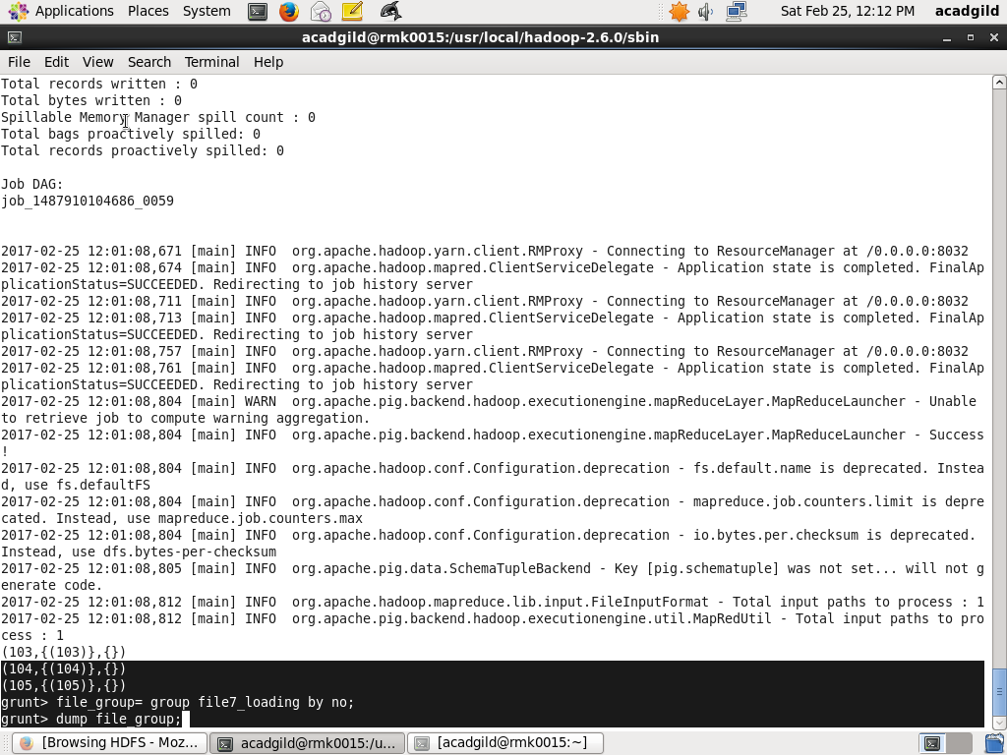

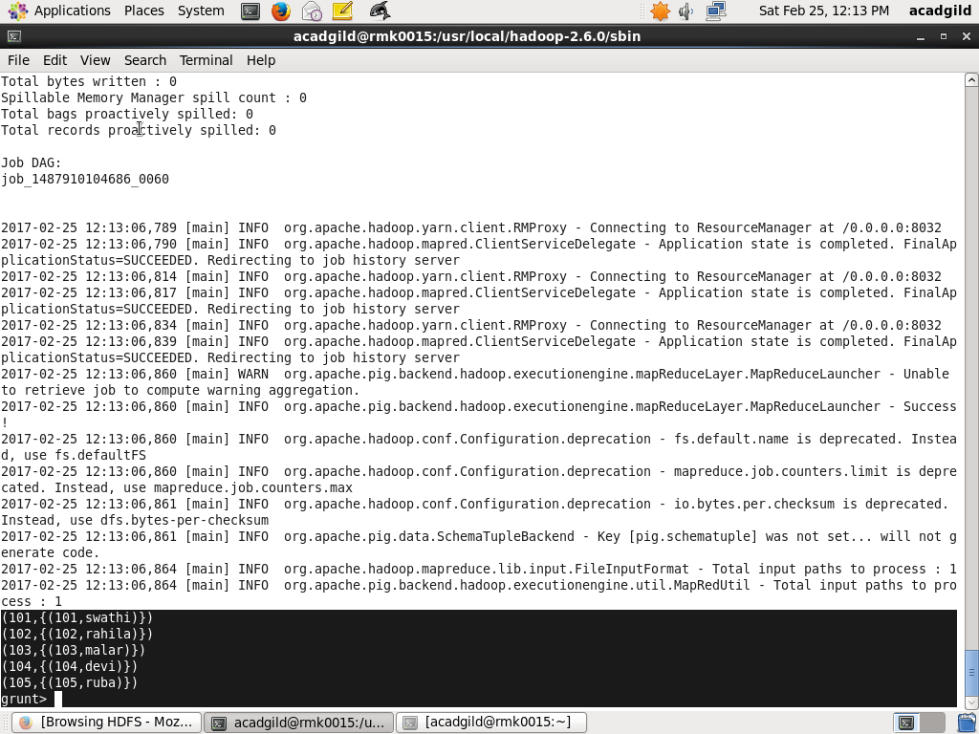

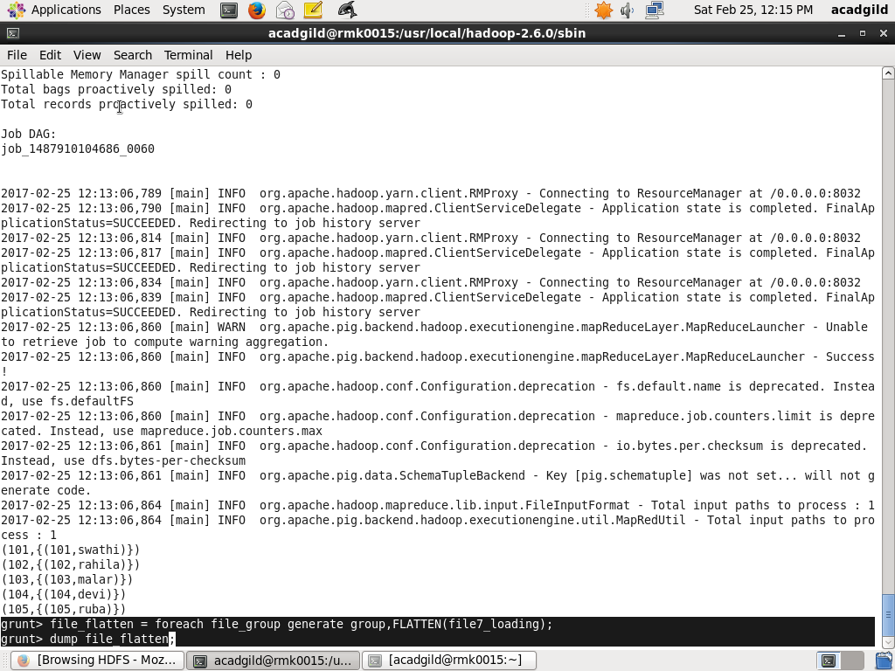

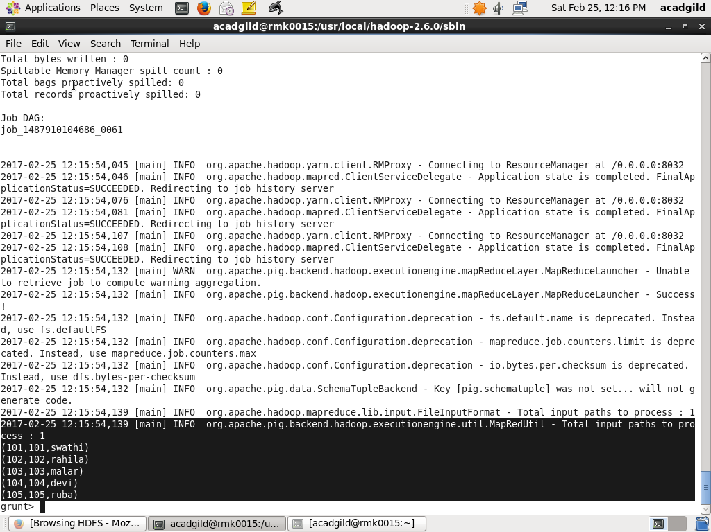

**IsEmpty:**

Checks if a bag or map is empty.

Syntax:

IsEmpty(expression)

Create the 2 files which are file6 and file9. Both the files are loaded into file6_loading and file9_loading seperately. Apply the cogroup commnd to group the files by number which is no. Finally apply the IsEmpty command for only keep those number’s which there is no name:

